ASP.NET Core Web API using ADO.NET
Building an ASP.NET Core Web API using ADO.NET allows you to create high-performance services with raw control over SQL queries, circumventing the overhead of an Object-Relational Mapper (ORM) like Entity Framework Core. [1, 2]
Below is a step-by-step implementation guide for setting up a controller-based Web API using modern ADO.NET practices with SQL Server. [1, 2]

- Make sure that the database MyDB is ready. (Refer to Prepare MyDB exercise)
- Create a new WebAPI Core project (using controller) name it as WebAPIADO.
- Delete the Weather forecast controller under Controllers folder
- Open the Server Explorer
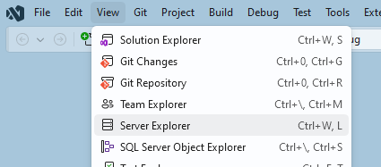

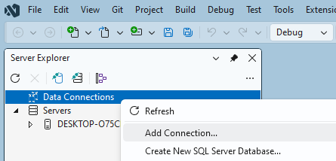

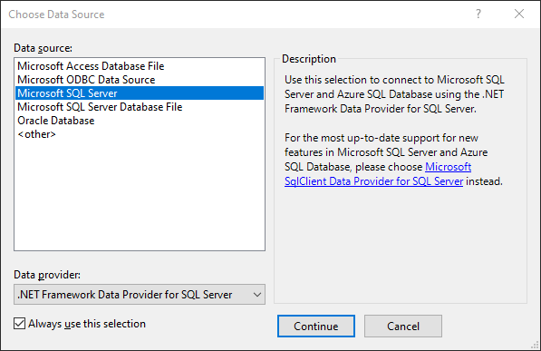

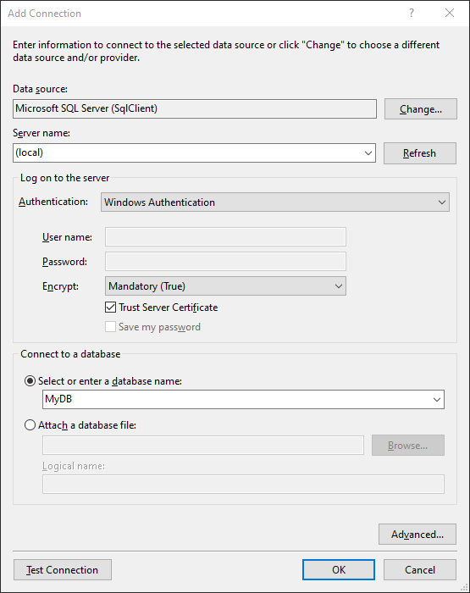
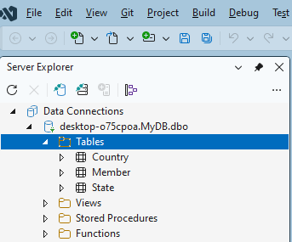

- Create a new Stored Procedure for MyDB
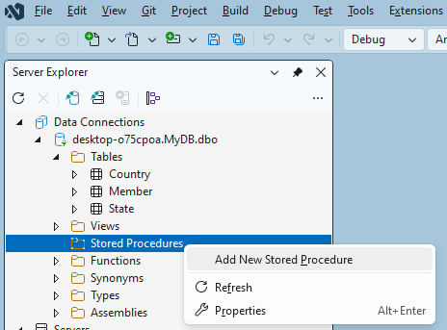

Replace the script with the following

CREATE PROCEDURE StatesByCountryName
@countryName varchar(128)
AS
SELECT s.* FROM State s
JOIN Country c ON s.Country=c.Code
WHERE c.Name=@countryName

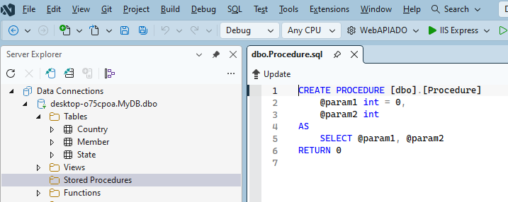

Run the script by right clicking+select Execute
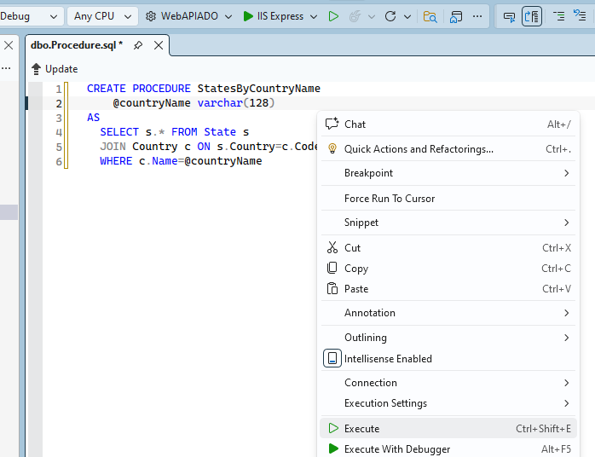
Refresh the Stored Procedure in Explorer
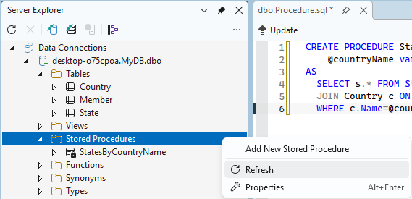

Try Execute the Stored Procedure
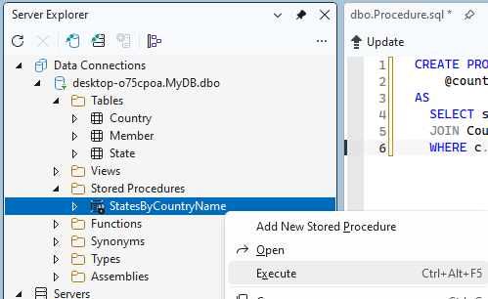

Type “Japan”
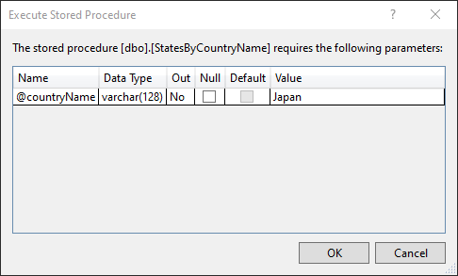
Result
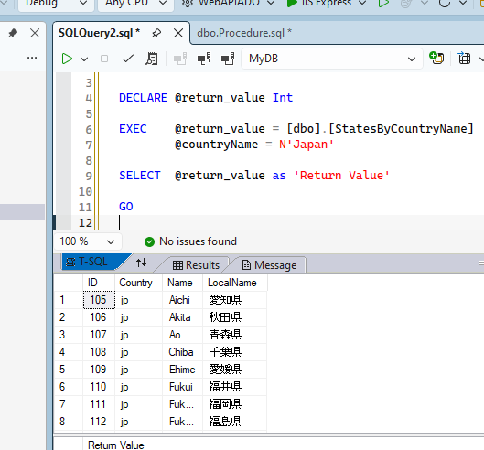
- Install the Modern Client Library
Instead of the legacy System.Data.SqlClient package, install the modern, officially supported Microsoft.Data.SqlClient NuGet Package by right click the project from Solution Explorer. Use Manage NuGet Packages.. to install the following:
- Microsoft.Data.SqlClient

- Configure the Connection String
Add your database connection configuration to the appsettings.json file: [1, 2]

{
"Logging": {
"LogLevel": {
"Default": "Information",
"Microsoft.AspNetCore": "Warning"
}
},
"AllowedHosts": "*",
"ConnectionStrings": {
"MyDB": "Server=(local);Database=MyDB;Trusted_Connection=True;TrustServerCertificate=True;Integrated Security=True;"
}
}
- Create the Model Class
Create a new Models folder, define State class matching the columns of the database table you want to query.

namespace WebAPIADO.Models {
public class State {
public int Id { get; set; }
public string Country { get; set; }
public string Name { get; set; } = string.Empty;
public string LocalName { get; set; } = string.Empty;
}
}

- Implement the API Controller
Create a State controller inheriting from ControllerBase. Inject IConfiguration via the constructor to access the connection string, then use standard ADO.NET workflows (SqlConnection, SqlCommand, SqlDataReader) to fetch and return data:
using Microsoft.AspNetCore.Http;
using Microsoft.AspNetCore.Mvc;
using Microsoft.Data.SqlClient;
using System.Data;

using WebAPIADO.Models;

namespace WebAPIADO.Controllers {

[ApiController]
[Route("api/[controller]")]
public class StateController : ControllerBase {
private readonly string _connectionString;

public StateController(IConfiguration configuration) {
// Retrieve the connection string dynamically from appsettings.json
_connectionString = configuration.GetConnectionString("MyDB")
?? throw new InvalidOperationException("Connection string not found.");
}

// HTTP GET: api/state
[HttpGet]
public async Task<IActionResult> GetAllStates() {
var states = new List<State>();
string query = "SELECT Id, Country, Name, LocalName FROM State";

// "using" blocks ensure connections and commands are properly closed & disposed
using (var connection = new SqlConnection(_connectionString)) {
using (var command = new SqlCommand(query, connection)) {
try {
await connection.OpenAsync();
using (var reader = await command.ExecuteReaderAsync()) {
while (await reader.ReadAsync()) {
states.Add(new State {
Id = reader.GetInt32(0),
Country = reader.GetString(1),
Name = reader.GetString(2),
LocalName = reader.GetString(3)
});
}
}
} catch (SqlException ex) {
return StatusCode(StatusCodes.Status500InternalServerError,
$"Database error: {ex.Message}");
}
}
}
return Ok(states);
}

// HTTP GET: api/state/{countryName}
[HttpGet("{countryName}")]
public async Task<IActionResult> GetAllStatesByCountryName(string countryName) {
var states = new List<State>();
string query = "StatesByCountryName";

// "using" blocks ensure connections and commands are properly closed & disposed
using (var connection = new SqlConnection(_connectionString)) {
using (var command = new SqlCommand(query, connection)) {
command.CommandType = CommandType.StoredProcedure;
command.Parameters.Add("@countryName", SqlDbType.VarChar, 128);
command.Parameters["@countryName"].Direction = ParameterDirection.Input;
command.Parameters["@countryName"].Value = countryName.Trim();
try {
await connection.OpenAsync();
using (var reader = await command.ExecuteReaderAsync()) {
while (await reader.ReadAsync()) {
states.Add(new State {
Id = reader.GetInt32(0),
Country = reader.GetString(1),
Name = reader.GetString(2),
LocalName = reader.GetString(3)
});
}
}
} catch (SqlException ex) {
return StatusCode(StatusCodes.Status500InternalServerError,
$"Database error: {ex.Message}");
}
}
}
return Ok(states);
}
// HTTP DELETE: api/state/{id}
[HttpDelete("{id}")]
public async Task<IActionResult> StateById(int id) {
string query = $"DELETE State WHERE ID={id}";
int n = 0;
using (var connection = new SqlConnection(_connectionString)) {
using (var command = new SqlCommand(query, connection)) {
try {
await connection.OpenAsync();
n = await command.ExecuteNonQueryAsync();
} catch (SqlException ex) {
return StatusCode(StatusCodes.Status500InternalServerError,
$"Database error: {ex.Message}");
}
}
}
if (n == 0) return NotFound();
return Ok();
}

}
}

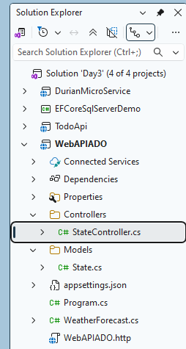

- Test with EndPoint Explorer
Delete the existing Weather forecast EndPoint. Generate new request script, change and test
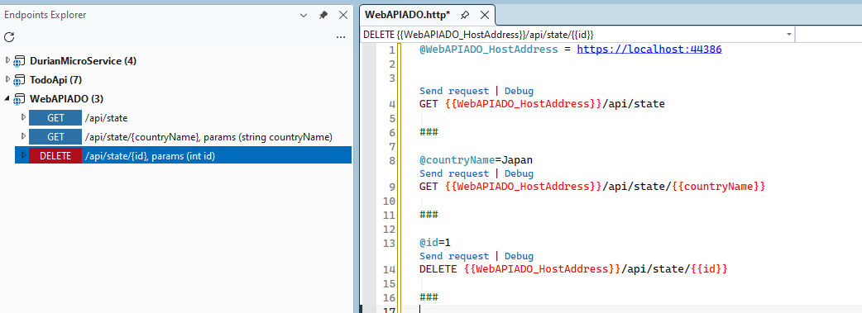

ADO.NET vs. Entity Framework Core in Web APIs
Feature | ADO.NET | EF Core
Performance | Blazing fast; minimal memory footprint. | Slight overhead due to LINQ translation & object tracking.
Control | Full control over precise SQL statement tuning and stored procedures. | Abstracted; queries are automatically generated.
Development Speed | Slower; requires manual data binding/mapping boilerplate. | Faster; handles mapping, migrations, and database schemas out of the box.

